Service Deliveries
Services delivered to consumers are documented in the Service Deliveries page of the consumer record. Service delivery may be documented by adding a service delivery in the consumer record.

The Service Deliveries list view contains a list of services delivered to or on behalf of consumers. Users access Service Deliveries to view and/or edit services that have been delivered, record delivery of new services, and delete services documented in error.

Several functions are available from the list view through the page menu. These functions are also available by right clicking anywhere in the list view. As with any page in SAMS, only those functions available to your user role and security permissions will be available.

- Add New - allows users to add new service deliveries.

- Open - opens the selected service delivery record in edit mode (or read-only mode if user does not have edit privileges). Users can also open the record by clicking the Open icon under Row Actions in the selected list item. Users can also double click the list item to open the record. See Editing a Service Delivery for more information.

- Delete - deletes the selected record. If the user has delete access, the Delete icon will be available under Row Actions in the selected list item. See Deleting a Service Delivery for more information.

- Copy - creates a new service delivery record based on the selected record and opens it in edit mode. All fields are filled with the original record's data except Service Month (which is prompted before creating the record) and Units which defaults to 1. See Copying a Service Delivery for more information.

- Other List Screen functions - Format Columns, Refresh, and Exporting or Printing Lists are also available.

Adding a New Service Delivery
The Add New button on the Service Deliveries list view page menu allows users to add new service deliveries to a single consumer.
►To Create a New Service Delivery

- Click in the Search Box at the top of the page.

2. Enter the consumer’s last name, first name.

3. Click on the consumer name. Note: Check the date of birth and county before selecting to make sure you have the correct consumer.

4. Click Service Deliveries tab.
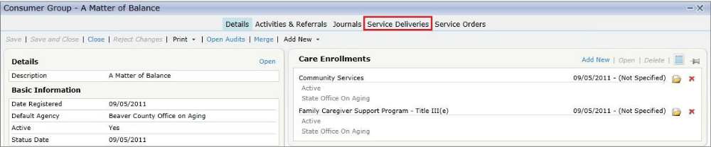

5. List view will display all service deliveries for selected consumer.
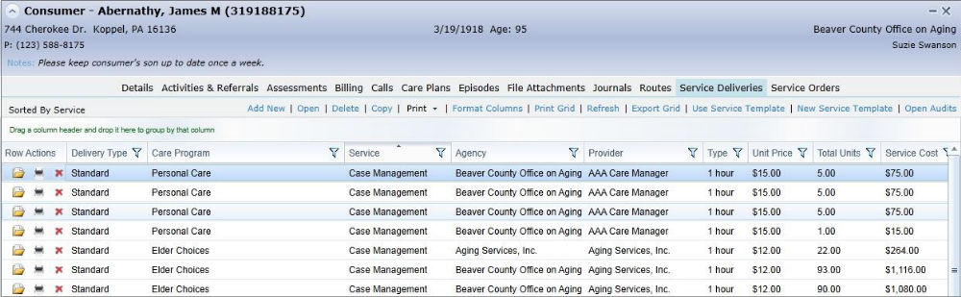

6. Click Add New to open the New Service Delivery edit screen.
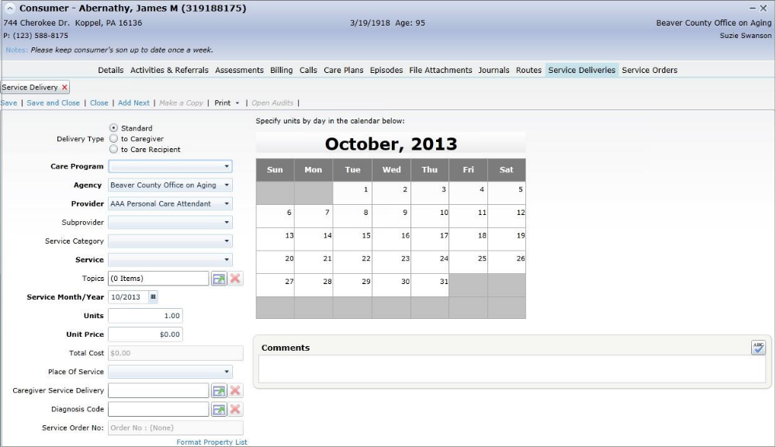

6. Select Delivery Type (Standard) for Care Program (Traditional OAA). These Care Programs are recorded under the consumer’s detail screen
OR Select Delivery Type (To Caregiver) for Care Program (National Family Caregiver Program and Alzheimer’s Respite). This Care Program is recorded under the Caregiver’s detail screen and the Care Recipient name must be entered on the service delivery.
7. Enter Agency (6_Central Ohio Area Agency on Aging), and Provider (Your organization)
8. Select Subprovider and Service Category as applicable.
9. Select Service from dropdown. Only services allowed under the selected care plan are available. Unit Price will prepopulate with defined unit price for the service. NOTE: Adult Day Service is only for Title III, Alzheimer’s Adult Day Service is only for Alzheimer’s Respite etc.

10. Enter the number of units for the month.

11. Enter the Full Unit Rate from your budget, not the reimbursable rate.

12. Select the Fund Identifier (Title III-B, Title III-C1, Title III-C2, or Title III-E)

13. Click Save and Close

Copying a Service Delivery
SAMS allows you to Copy an existing service delivery updating only the date of service. This is useful for Consumers or Consumer Groups that receive the same service on a monthly basis.
►To Copy a Service Delivery
- Click in the Search Box at the top of the page.

2. Enter the consumer’s first and last name.

3. Click on the consumer name. Note: Check the date of birth and county before selecting to make sure you have the correct consumer.

4. Click Service Deliveries tab. List view will display all service deliveries for selected consumer.

5. Highlight the service delivery you wish to copy and Click Copy.
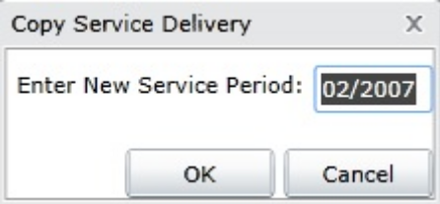

6. Enter the New Service Period for the Service Delivery and click OK.
7. The new Service Delivery is displayed.

8. Modify any service fields as needed.
9. Click Save to save the record or Save and Close to save and close the record.

