Adding a Consumer
SAMS allows users to add new consumers to receive services from the organization. To maintain data integrity and reduce duplicative data entry, SAMS automatically checks any new consumer to be added against existing consumers in the database. Depending on organizational security configuration, duplicate consumers may be displayed upon attempting to add a new consumer record.

►To add a new consumer

To access the Consumer list screen follow the steps below:
1. Click Consumers on the toolbar.

2. Consumer list view will open.
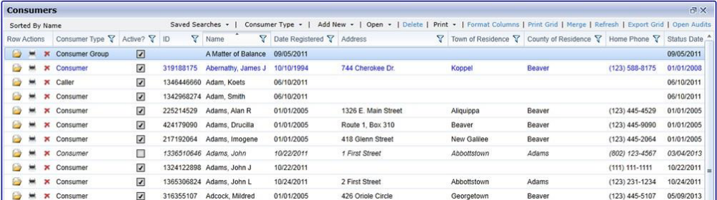

3. Click Add New in the page menu.
-OR-
Right Click anywhere on list to expose menu and select Add New.

4. Register Consumer Dialog will open.
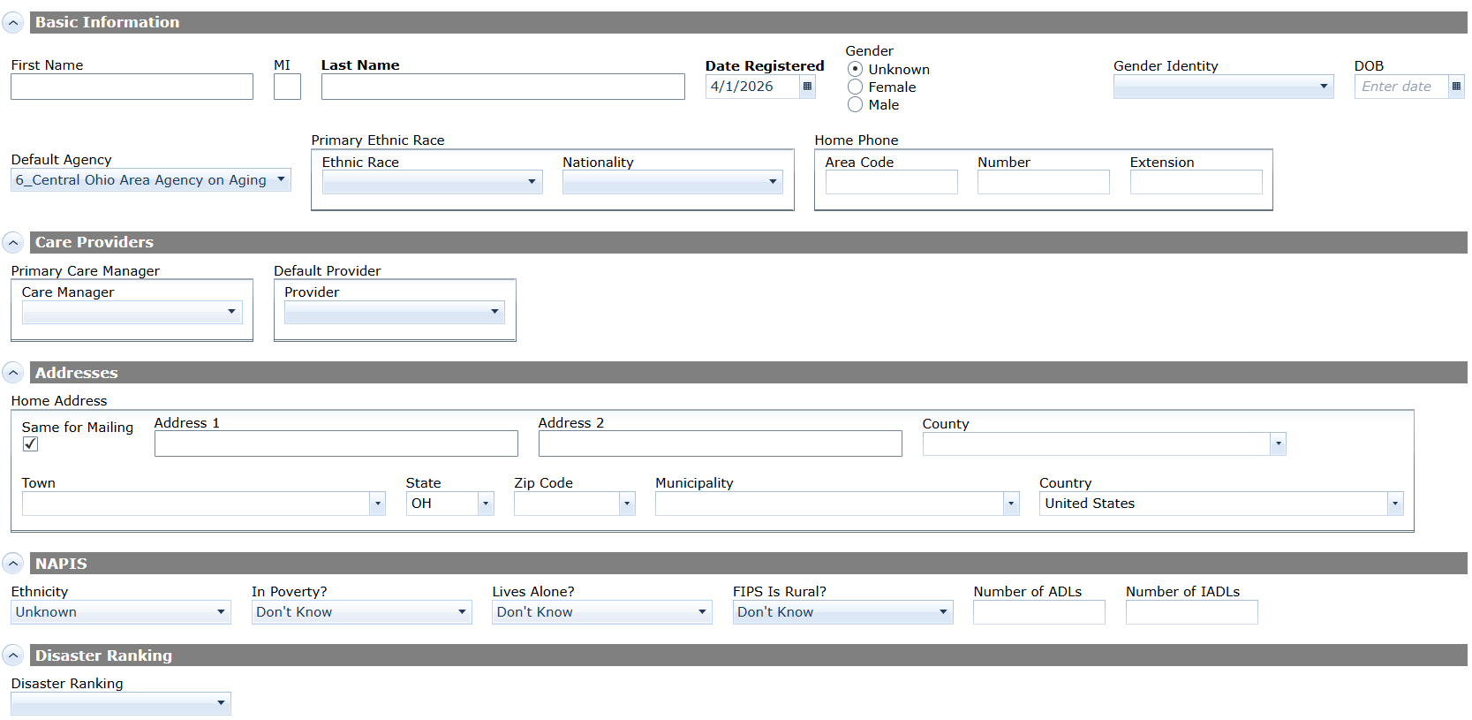

5. If you enter information in two fields for a consumer that matches information for one or more existing consumer records, depending on your agency's security configuration, you will be presented with possible matches when you click in a third field.
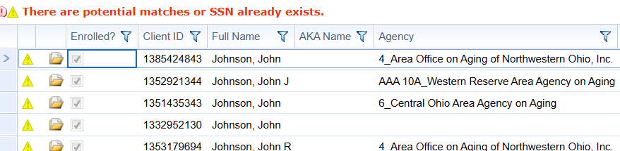

6. To begin editing the matched record, click the Open icon. A dialog will appear to confirm that you want to open the record and delete any information you may have entered. Click OK to open the Consumer Details page for the matched consumer. Click Cancel to return to the Register Consumer dialog.
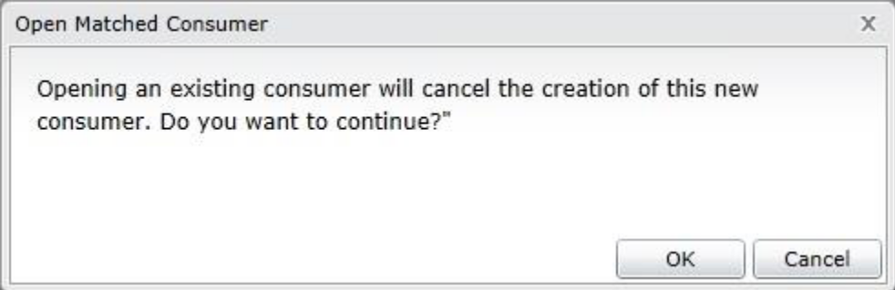

8. If no matched records appear or the matched records do not match the new consumer, enter any additional information, and click OK to add the consumer and open the Consumer Details page. Click Cancel to return to the Consumer list view without adding the consumer.
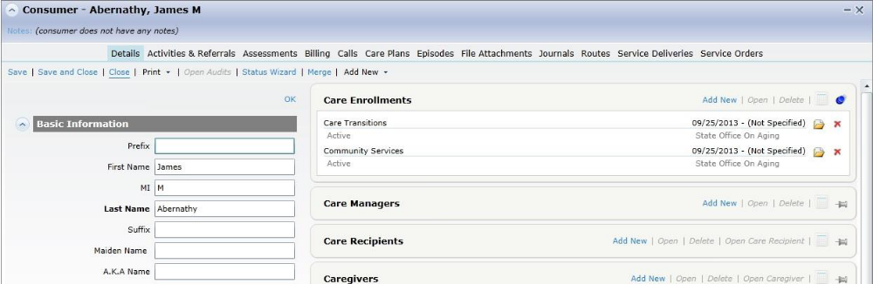

9. Enter additional information in the Consumer Details screen. The Consumer Details tab or page displays the demographic, contact, and program enrollment and eligibility details for a specific consumer as well as other information about persons associated with the consumer, such as caregivers and contacts, and other information relevant to reporting requirements. At minimum, you must add at least one care enrollment.
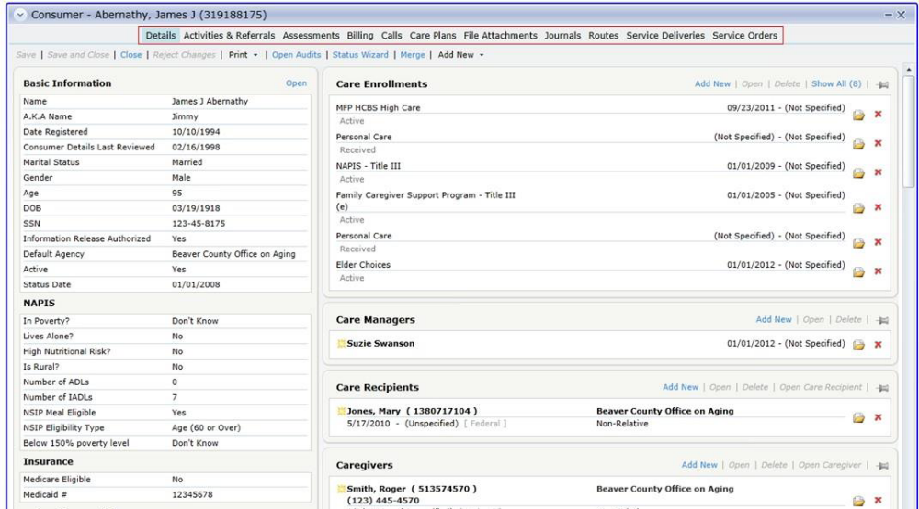

The Consumer Details page is divided into two sections. The left side of the page displays identifying information, such as name, date of birth, and numeric identifiers; demographic information such as ethnicity and poverty status; and other information, such as information relevant to NAPIS and or state reporting. The right side displays detail subpages of information associated with the consumer, such as contact information like addresses and phone numbers; associated care givers, care recipients, and contacts; eligibility and enrollment information; and other information. Some detail subpages are available to add new information or edit existing information, and some are read-only. By default, detail subpages show a summary of information they contain. When opened, they expand to show detailed information in the specific record.
The information below is required for Title III or Alzheimer’s Respite recipients:
Click OPEN next to Basic Information to enter the following:
• First Name - Consumer's first name.
• Last Name - Consumer's last name.
• Date Registered - Date the consumer was first entered in the system. Defaults to current date upon add. This date must be prior to the date of the first service delivery
• Gender Identity - Consumer's gender identity. This is a required field, but dropdown defaults to "Unknown" on add.
• Birth Date - Consumer's date of birth.
• Default Agency – This must be 6_Central Ohio Area Agency on Aging.
• Active - Indicates whether the consumer is actively being provided care by the organization. Typically, consumers no longer receiving services for a variety of reasons are inactivated, but not deleted or removed from the system. This is a global setting for the consumer record, not specific to individual providers or agencies. This field defaults to "Active" upon add. Deactivating a consumer must be confirmed by the user.
• Ethnicity - Documents the Federal government ethnicity designation of Hispanic or non-Hispanic. Dropdown defaults to "Unknown" on add.
• In Poverty - Documents consumer's poverty status for NAPIS reporting. Status defaults to "Don't Know" upon add.
• Lives Alone - Documents, for NAPIS reporting, whether consumer lives alone. Status defaults to "Don't Know" upon add.
• Is Rural - Documents, for NAPIS reporting, whether consumer lives in a rural area. Status defaults to "Don't Know" upon add.
• Number of ADLs - Documents number of ADLs with which the consumer needs assistance. Defaults to zero upon add.
• Number of IADLs - Documents number of IADLs with which the consumer needs assistance. Defaults to zero upon add.
Click Add New to enter the following required information:
• Care Enrollments - SAMS will not save a new consumer record without at least one care enrollment (Alzheimer’s Respite and/or Traditional OAA).
• Ethnic Race - Documents information about the consumer's ethnicity and race. See "Ethnic Races" for more information.
• Providers - Documents information about providers from which the consumer receives care. See "Providers" for more information.
• Disaster Ranking – Documents the level of risk a consumer would be considered at in the event of a crisis.

10. Click Save to save consumer details and leave the consumer record open. Click Save and Close to save consumer details and close the consumer record and return to the Consumer list view. Click Close to close the consumer record without saving. Click Add Next to save the current consumer and add a new one.

